Elevator Control System
Digital logic semester project
Spring 2025


Group Members:
Hadi Aqeel (23i-6136)
Jamal Nasir (23i-6196)
Sarmad Malik(23i-6005)

Submission Date:
30th March 2025

Abstract:
Elevators are essential in every high story building; they act as a practical and Familiar system to implement through digital logic. This project also acts as a Bridge between academic concepts and real-life applications. The implementation of such a project allowed us to use a range of different logic gates and ICs that are commonly used in digital logic, these included simple logic gates like AND, OR, NOT, (both 2 and 3 input), multiplexers and encoders (7 input priority encoder) and sequential logic circuits e.g. T Flip Flops, D type registers and counters.
We were able to make 3 floor elevator with movements based on user inputs for both inside and outside the elevator providing floor priority based on directional control and elevator position along with a 10sec delay through a clock for more realism.

Objectives
Main Objective:
The primary goal is to design and implement a multi-floor elevator control system without the use of a microcontroller or PLC by utilizing basic digital logic components.
Sub-Goals:
- Circuit simulation:
- Create and evaluate the elevator control logic using the Proteus simulation program.
- Verify the feasibility of logic circuits such as flip-flops, counters, demultiplexers and encoders and ensure that they’re working correctly.
- Test logic for directional control unit and up and down counters.

- Hardware Implementation:
- Assemble the designed circuit on a breadboard using a multitude of digital logic ICs, keeping in mind the multiple Vcc power and ground pins along with different enable and active high/low configurations for specific ICs.
- Demonstrate functional elevator operation for multiple floor requests.

- Logic for Handling Requests:
- To store floor and direction requests, use latching mechanisms.
- Use encoders and demultiplexers to rank requests according to the elevator's current position and direction.

- Display output:
- Use of 7 segment displays to produce wait time counters and elevator floor position.

Work distribution:
- Hadi Aqeel (23i-6136):
Worked on logic formulation of elevator movement and on the complete Porteus simulation along with video production for project submission. Report writing.

- Jamal Nasir (23i-6197);
Worked on Physical implementation on breadboard along with testing and PowerPoint presentation.

- Muhammad Sarmad Malik(23i-6005):
Worked on physical implementation on breadboard along with project proposal and report writing.

Components used:

Component | Part Number | Quantity
2-input OR Gate | 7432 | 7
3-input OR Gate | 4075 | 5
NOT Gate | — | 8
JK Flip-Flop | 74HC76 | 5
3-to-8 Line Decoder/Demultiplexer | 74HC238 | 2
3-input AND Gate | 4073 | 12
8-input Priority Encoder | 4532 | 2
2-input AND Gate | 7408 | 5
D-Type Positive-Edge Triggered Flip-Flop | 74174 | 1
Quad JK Edge-Triggered Flip-Flop with Set/Reset | 74276 | 1
7-Segment Display | — | 2
Push Buttons | — | 7

Circuit simulation
- Latching section:

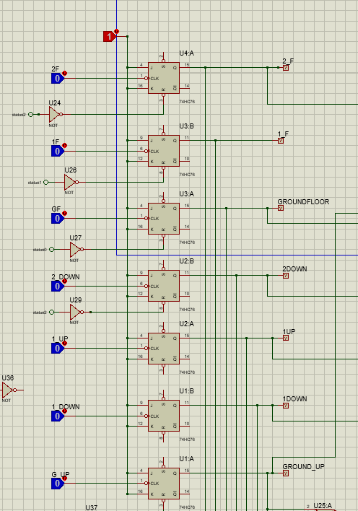
Figure 1Latching inputs for both inside and outside the elevator

Brief high pulses are produced by button inputs from every floor, whether they are internal car-request buttons or external floor-call buttons. JK flip-flops, which toggle to store these requests, are used to capture them. This configuration makes it possible to hold several requests at once until they are completed.

- Directional control unit:

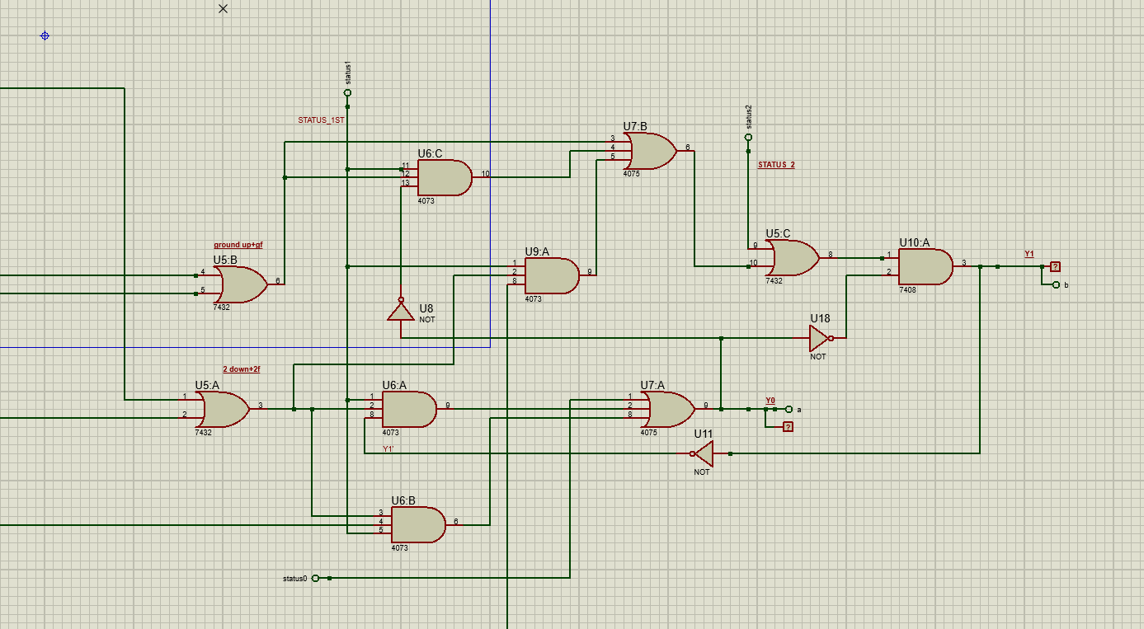
Figure 2 Direction control unit

This unit uses logic equations to determine whether the elevator should move up or down, depending on its current floor and active requests. Logical flags indicate the elevator’s current status, and based on these flags, movement outputs Y₀ (up) or Y₁ (down) are generated.
This section uses the highest amount of logic gates and is a complex block with multiple combinational circuits overlapping each other while also taking inputs from the floor status of the elevator to determine direction.
Logic equations for Y(0) and Y(1):
Y0: STATUS_GROUND+(2_DOWN+2F). Y1.STATUS_1ST .(2_DOWN+2F).1_UP
Y1: =[STATUS_1ST.(G_UP+GF).Y0 (G_UP+GF) . STATUS_1ST.(2_DOWN+2F) .1_DOWN+STATUS_2ND].Y0

- UP/Down counter:
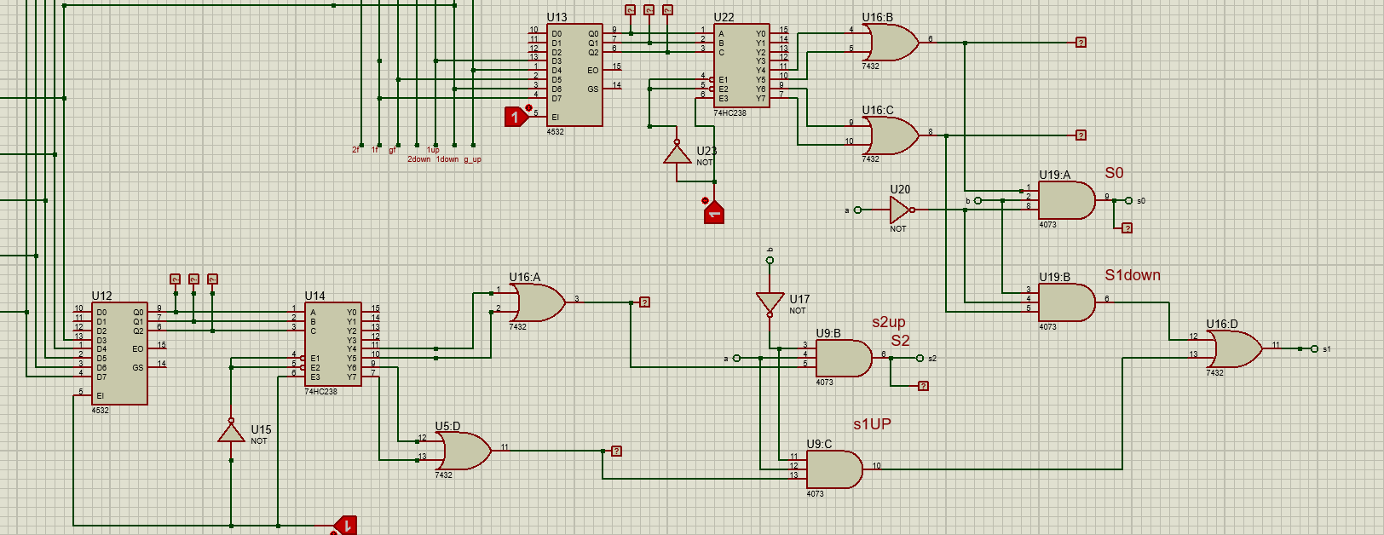
Figure 3 up and down counter using priority encoder and demultiplexer

Every input signal to the encoder is being given priority, with D7 having the highest priority and D0 the lowest. The 1st floor, this being the central location in the elevator system, automatically deserves the highest priority. The encoding logic further breaks down into two parts-handling of upward journey and handling of downward journey. The active user requests and the current position of the elevator will be used to logically synthesize the unique binary code through a series of logic gates and demultiplexer that represent the target floor. The output lines S0, S1, and S2 work independently such that only one will be high at the time, denoting the selected floor.
- Display unit
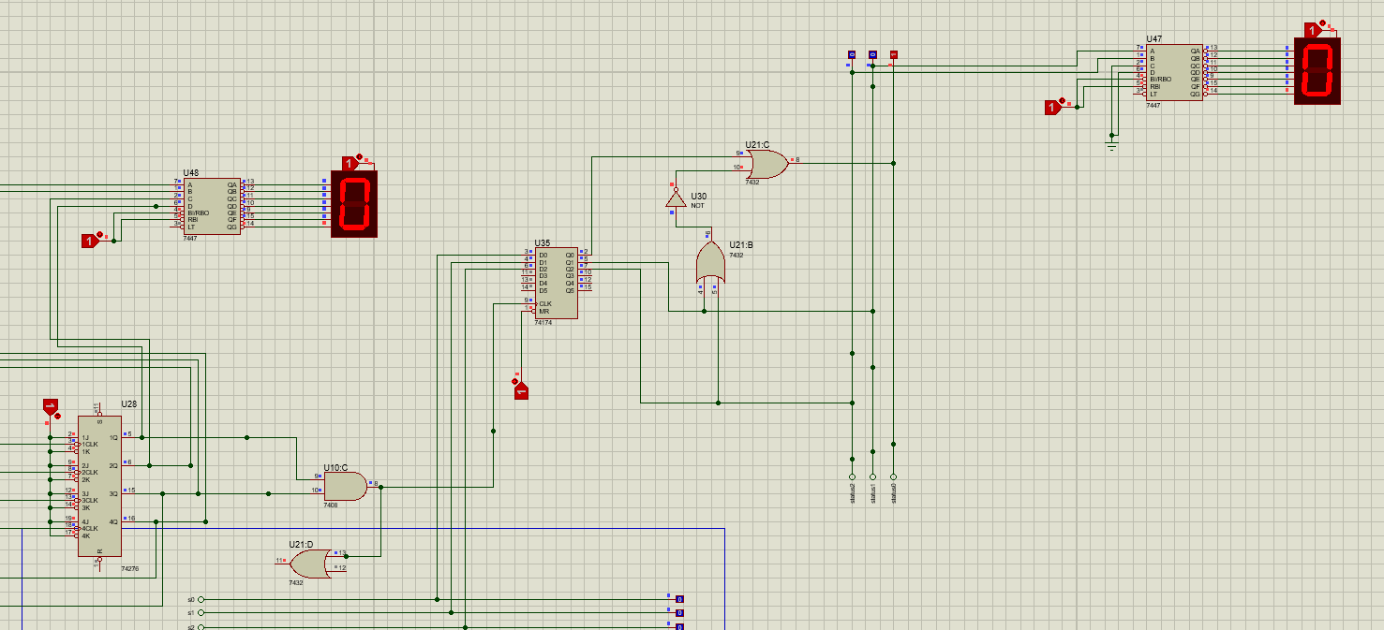
Figure 4 showing floor number and waiting time
Outputs are shown on the 7 segment display, registers are only used to make sure clock is only updated when the clock pulses, the lefts side shows a counter the increments the 10 sec delay timer.

Circuit outputs
Truth Tables:

Truth Table of Elevator Position for Upward Direction (Y0=1, Y1=0)
Q2 | Q1 | Q0 | Y7 | Y6 | Y5 | Y4 | S2 | S1 | S0 | Position
1 | 1 | 1 | 1 | 0 | 0 | 0 | 0 | 0 | 1 | 1st Floor
1 | 1 | 0 | 0 | 1 | 0 | 0 | 0 | 0 | 1 | 1st Floor
1 | 0 | 1 | 0 | 0 | 1 | 0 | 1 | 0 | 0 | 2nd Floor
1 | 0 | 0 | 0 | 0 | 0 | 1 | 1 | 0 | 0 | 2nd Floor

Truth Table of Elevator Position for Downward Direction (Y0=0, Y1=1)
Q2 | Q1 | Q0 | Y7 | Y6 | Y5 | Y4 | S2 | S1 | S0 | Position
1 | 1 | 1 | 1 | 0 | 0 | 0 | 0 | 0 | 1 | 1st Floor
1 | 1 | 0 | 0 | 1 | 0 | 0 | 0 | 0 | 1 | 1st Floor
1 | 0 | 1 | 0 | 0 | 1 | 0 | 1 | 0 | 0 | Ground Floor
1 | 0 | 0 | 0 | 0 | 0 | 1 | 1 | 0 | 0 | Ground Floor

Q2 Q1 Q0: output from encoder
Y7–Y4: Decoder outputs; only one is HIGH depending on Q2–Q0

Hardware Implementation
Overall circuit:
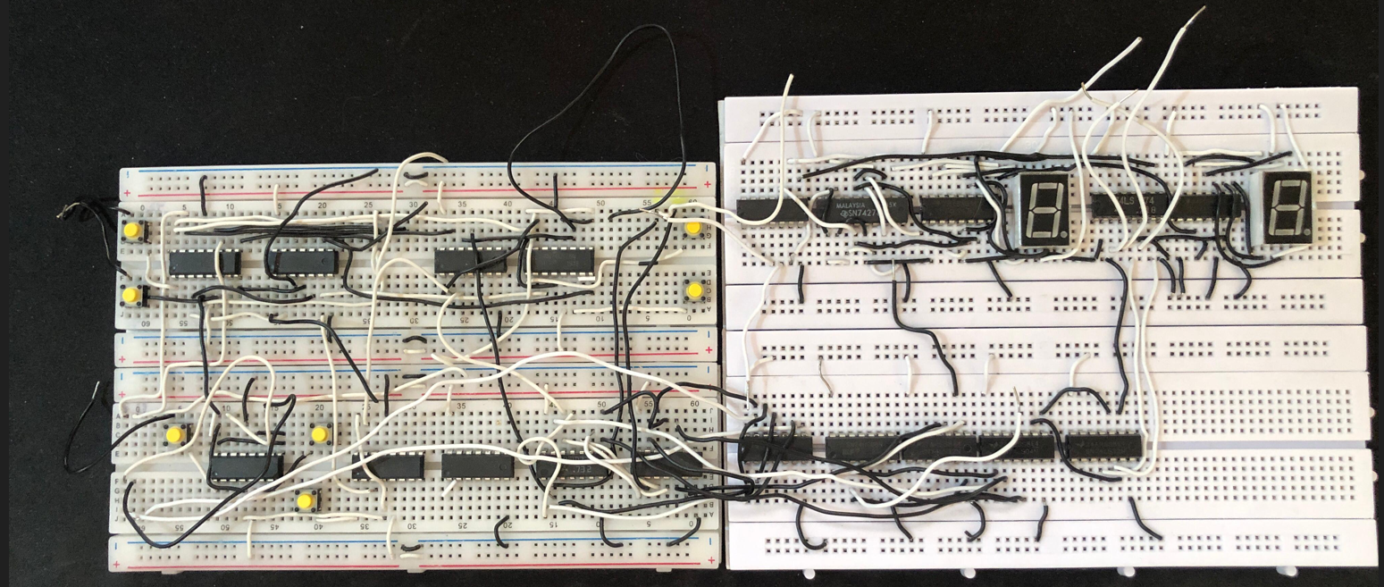
Figure 5 Overall circuit
- Latching section:

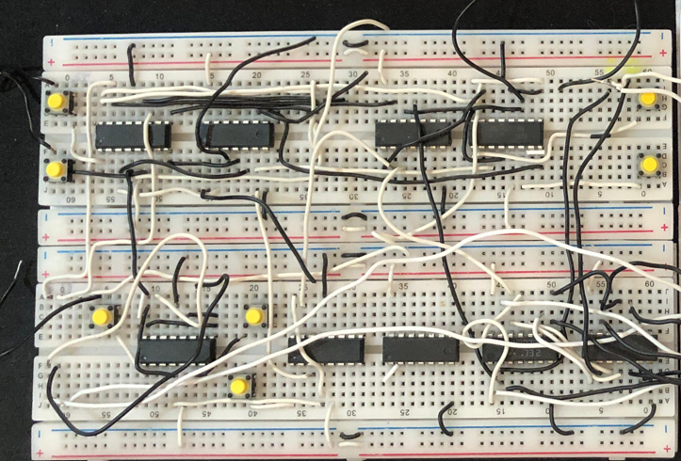
Figure 6(use of push button for user input)

- Priority encoding
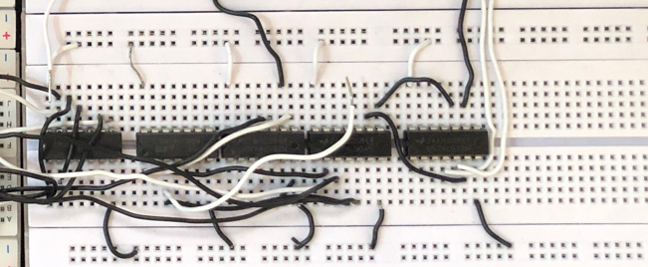

- Display unit
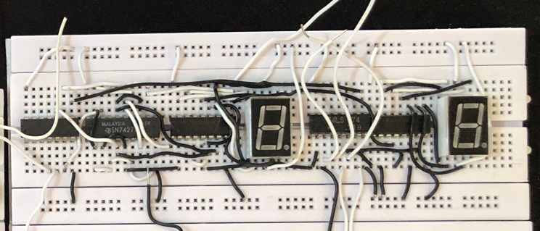

Testing and Results
While the final hardware setup did not perform as expected, the testing phase provided valuable insights into the practical challenges of translating simulated logic into real-world circuits. A solid foundation was established by the Proteus simulation's accurate logical behavior and flow. Due to lack of market availability of a few ICs the project couldn’t be completed.

Challenges faced

- One of the main issues faced was the unavailability of specific ICs, this limited out ability to replicate the circuit physically and he had to try substitutes which look a lot of time.
- The sheer number of interconnected logic gates, flip-flops, encoders, and decoders made the circuit highly intricate. This complexity led to confusion during wiring and made troubleshooting more difficult.
- With multiple ICs requiring different power and ground configurations, ensuring consistent voltage levels across the circuit became challenging

Conclusion
Through the design and simulation of our elevator control system, we gained a deep, hands-on understanding of how real-world embedded systems problems can be solved using only fundamental digital logic components. Furthermore, we learned how to break down complex behaviors—like request handling, direction control, priority decision-making and how theoretical concepts can be applied to make digital systems that model a practical application

